**Car Performance Prediction**

**1.1 INTRODUCTION**

Artificial Intelligence is the simulation of human intelligence processes by machine, especially computer systems. These processes include learning, reasoning and self-correction. Particular application of AI includes expert system, speech recognition and machine vision. Popular AI cloud offering includes Amazon AI services, IBM Watson Assistant, Microsoft cognitive services and Google AI services.

Examples of AI technology:

1. Machine Learning
2. Natural language processing (NLP)
3. Robotic
4. Self-driving cars

**Machine Learning**

Machine is the part of Artificial intelligence that allows computer system to learn from examples, data and experience. Through enabling computers to perform specific tasks intelligently, machine learning systems can carry out complex processes by learning from data, rather than following pre-programmed rules. It includes algorithmic interpretability, robustness, privacy, fairness, inference of causality, human-machine interaction, and security

**Python for Machine Learning**

Machine learning focuses on the development of Computer Programs that can change when exposed to new data. In this Project we’ll implement a simple machine learning algorithm using python. Python is an interpreted, object- oriented, high level programming language with dynamic semantics. Python is widely used for data analytics. Almost all cloud platforms offer support and often new features becomes available in Python first.

**Anaconda**

Directly from the platform and without involving DevOps, data scientists can develop and deploy AI and machine learning models rapidly into production. Anaconda provides the tools needed to easily:

* Collect data from files, databases, and data lakes
* Manage environments with Conda
* Share, collaborate on, and reproduce projects

**1.2 OBJECTIVES OF RESEARCH:**

The main objective of this performance analysis to predict the car performance based on the brand engine cylinder and high way MPG. These are the factors on which the health of the car can be predicted. It is an on-going process of obtaining, researching, analyzing and recording the health based on the above three factors. The performance objectives like speed, dependability, flexibility and cost can be grouped together to play a vital role in prediction engine and engine management system. Optimization on a high dynamic test bed can be done very effectively by simultaneously considering performance, fuel-consumption, emission and driveability. This approach is the very important step towards understanding the vehicles performance.

**1.3 PROBLEM STATEMENT**

Predicting the price and the performance level of cars in both an important and interesting problem. Predicting the value of a car is not a simple task. It is trite knowledge that the value of used cars depends on a number of factors. The most important ones are usually the make (and model), the origin of the car (the original country of the manufacturer), its mileage (the number of kilometers it has run) and its horsepower. Due to rising fuel prices, fuel economy is also of prime importance. Unfortunately, in practice, most people do not know exactly how much fuel their car consumes for each km driven. Other factors such as the type of fuel it uses, the interior style, the braking system, acceleration, the volume of its cylinders (measured in cc), safety index, its size, number of doors, year etc. As we can see, the price depends on a large number of factors. Unfortunately, information about all these factors are not always available and the buyer must make the decision to purchase at a certain price based on few factors only. In this work, we have considered only a small subset of the factors mentioned below.

**2. REVIEW OF LITERATURE**

According to Venkataramani, the “Project report for Manufacture of passenger cars and light utility vehicles”, dated 27. May 1982 revealed that among the major goals associated with Maruti were: Modernization of the Indian automobile industry; Production of fuel efficient vehicles; A large output of motor vehicles; Import of foreign technology and equity participation by the collaborator Production of a “people’s car” suited to Indian driving and climatic conditions; Creating potential for earning foreign exchange by export of Maruti products; and Generating employment through establishment of ancillary industries “The survey of potential purchasers drawn from nine cities which then accounted for 60% -70% of the country's car owning population revealed that 90% of car use was within a city, the individual car owner travels 800 km a month on an average and that the average number of passengers in a car was four because cars were largely used for office-going purposes. Also, only 20%-30% of the respondents indicated a desire to 88 purchase a car in the next two years at the existing prices, but for a new price range of between Rs.40.000 to Rs.55,000 the proportion of likely buyers went up to 43%-45%. Finally, the survey revealed that the two most important factors considered while purchasing a car were fuel efficiency and initial capital cost. Of the total sample, 37% preferred a small car and only 18% preferred a medium-sized car. so in order to predict the performance we consider more factors in futureNone

Ratan Binodini Amiya Priyadarsini (May 2013):As India’s economy continues to grow at a rapid pace, the automobile industry will be a key beneficiary. This is widely true across automotive markets—from those serving customers with four-wheelers to those offering commercial vehicles. The main factors behind such growth are the increasing affluence of the average consumer, overall GDP growth, the arrival of ultra-low-cost cars, and the increasing maturity of Indian original equipment manufacturers (OEMs). However, India’s path to mass motorization will be very different from that of developed countries; it must first develop the new technologies, business models, and government policies that will pave the way to increased automobile penetration. The automotive sector is one of the core industries of the Indian economy, whose prospect is reflective of the economic resilience of the country. This research paper are give the information for how the automobile sector has grown up in this city due to increasing the GDP rate in the city. Dr. H. S. Adithya (Jan 2013):Automobile Industry is one of the fastest growing sectors in our country. Cars were once considered as a luxury and now it has become a necessity. They have become a part and parcel of today’s life and most of the car manufacturers target the middle class segment to a great extent. The introduction of small cars is a classic example for this. Today’s consumer has plenty of options available to him. We are in a consumers market where the marketers do not merely satisfy a need but try to achieve consumer delight. The decision to purchase a car is not a one man decision. The purchase is normally influenced by many including their own perceptions and behaviour.The author has clearly define in this paper perception of consumer towards car owner and their behavior of purchasing decision. Every consumer decision different so they analysis then give the opinion.

Prof. Elizabeth Chacko, Ms. Punnya Selvaraj (2014):The Automobile Industry is growing and if compared the sales and production of four wheelers is more. Also if we compare the four wheeler models like car which can be driven by females were least in market because the market was male dominant. But now there is drastic change. Earlier car which can be driven by female was only Maruti 800, all other like Tata Sumo, Bolero, Ambassador etc. In this new era we can see segment for small four wheeler car quite large. This research paper has most innovative, author are analysis only female consumer Pattern and how they driving new car and also the purchasing pattern of their brand, Services, quality, mileage etc

Read

Unread

Starred

Unstarred

**1**–**50** of **303**

https://mail.google.com/mail/u/0/images/cleardot.gif

https://mail.google.com/mail/u/0/images/cleardot.gif

**3.DATA COLLECTION**

We used the data from the website “kaggle.com”.We have data about past and current employes in a spreadsheet on desktop.It has various data points on our employees.but most interested in whether they’re still with company or whether they’ve gone to work somewhere else.And we want to understand how this relates to workforce attrition.

**3.1 Primary Data Collection Method**

The primary data source is the most important aspect of any research as it is the initial point of

starting the dissertation. Hence it requires to be genuine and must provide accurate data with

evidence. In this research, the primary data was collected by the study on various research papers and case studies on employee attrition, predicting employee attrition and Factors influencing retention. The weighting for each factor influencing the attrition was given after the survey was carried among the HR Managers and Professionals. The detailed information about the survey is given in “kaggle.com”.

**3.2 Secondary Data Collection Method**

Secondary data was used in my research for implementing the research technically. Thus, whateverwas studied theoretically, needed to be implemented practically wherein I referred to Technicalthesis and other research Journals for transforming business logic to technical implementation. Here, I studied about the Machine Learning Algorithms and how they can be implemented for predicting employee attrition and implementing decision tree for categorizing the valuable employee from ordinary one. I also studied about the previous implementations done by IBM Watson for workforce analytics and Talent Management tool (IBM Watson, 2018) and how I can improvise those tools and make considerable advancements in those.

**4. METHODOLOGY**

**4.1 Exploratory Data Analysis**

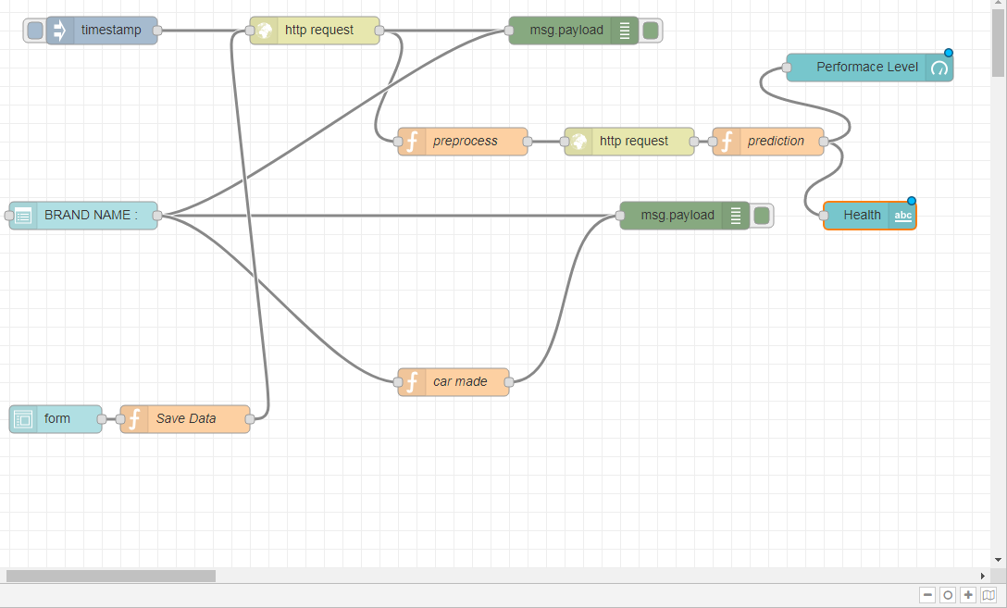

**Fig 4.1.1. Node-RED flow**

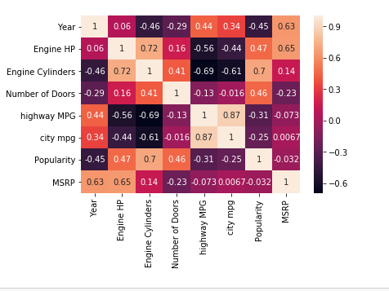

**Fig 4.1.2 Corelation**

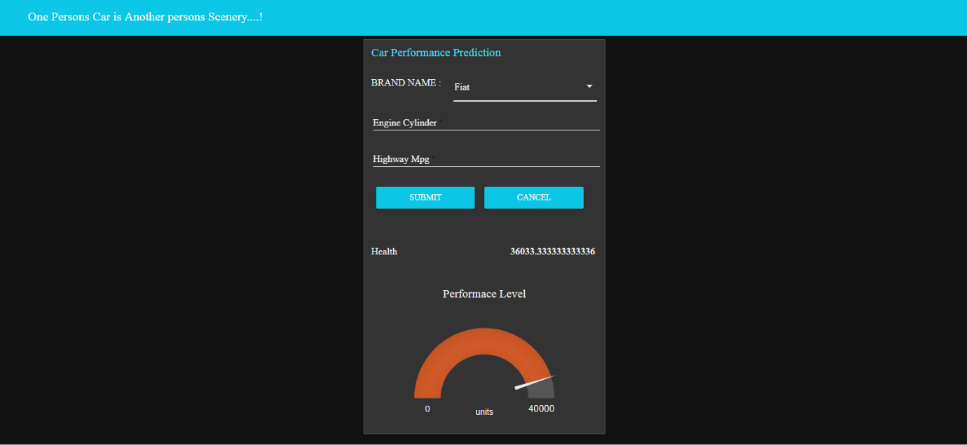

**Fig 4.1.3 User Interface**

**4.2 Data Modelling**

We have our final dataset.If you won’t have the true values how would you know that the predictions are correct. Now you will realize that, how important the training data phase is. We train the model in a way that it can predict(almost) correct results.In this dataset, we don’t have any missing values for Attrition, we will split the data into train and test. We will train the model on training data and predict the results on test data.For this particular exercise we will use k-nearest neighbors (KNN). Before jumping into code, let’s get a little background about the RF classifier. The k-nearest neighbors (KNN) algorithm is a simple, easy-to-implement supervised machine learning algorithm that can be used to solve both classification and regression problems.

**5. REFERENCES**

[1]NATIONAL TRANSPORT AUTHORITY. 2014. Available from: http://nta.gov.mu/English/Statistics/Pages/Archive.aspx [Accessed 15 January 2014].

[2] MOTORS MEGA. 2014. Available from: http://motors.mega.mu/news/2013/12/17/auto-market-8-decrease-sales-newcars/ [Accessed 17 January 2014].

[3] LISTIANI, M., 2009. Support Vector Regression Analysis for Price Prediction in a Car Leasing Application. Thesis (MSc). Hamburg University of Technology.

[4] RICHARDSON, M., 2009. Determinants of Used Car Resale Value. Thesis (BSc). The Colorado College.

[5] WU, J. D., HSU, C. C. AND CHEN, H. C., 2009. An expert system of price forecasting for used cars using adaptive neuro-fuzzy inference. Expert Systems with Applications. Vol. 36, Issue 4, pp. 7809-7817.

[6] DU, J., XIE, L. AND SCHROEDER S., 2009. Practice Prize Paper – PIN Optimal Distribution of Auction Vehicles System: Applying Price Forecasting, Elasticity Estimation and Genetic Algorithms to Used-Vehicle Distribution. Marketing Science, Vol. 28, Issue 4, pp. 637-644.

[7] GONGGI, S., 2011. New model for residual value prediction of used cars basedon BP neural network and non-linear curve fit. In: Proceedings of the 3rd IEEE International Conference on Measuring Technology and Mechatronics Automation (ICMTMA), Vol 2. pp. 682-685, IEEE Computer Society, Washington DC, USA.

[8] LEXPRESS.MU ONLINE. 2014. Available from: <http://www.lexpress.mu/> [Accessed 17 January 2014]

[9] LE DEFI MEDIA GROUP. 2014. Available from: <http://www.defimedia.info/> [Accessed 17 January 2014]

**6. CONCLUSION**

The main goal of the current study is to predict the performance of the car. This performance can help to improve the certain behaviour of the vehicle. This can significantly help to improve the systems fuel consumption and increase the efficiency. Therefore it is important to analyse the factors using number of well known approaches of machine learning algorithms like linear regression, decision tree and random forest to improve the vehicle performance efficiency. Through an comparative study between Brand name, Engine Cylinder, Highway MPG we are capable of predicting the performance.